ELECTROLYSIS

**Electrolysis and Electrolytic Cells**

A voltaic cell uses a spontaneous redox reaction to generate an electric [current](https://www.ck12.org/c/physical-science/current?referrer=crossref). It is also possible to do the opposite. When an external source of direct current is applied to an electrochemical cell, a reaction that is nonspontaneous can be made to proceed. A nonspontaneous reaction will have an overall standard reduction potential that is negative (E0 < 0). **Electrolysis** is the process in which

electrical [energy](https://www.ck12.org/c/physical-science/energy?referrer=crossref) is used to cause a nonspontaneous [chemical reaction](https://www.ck12.org/c/physical-science/chemical-reaction?referrer=crossref) to occur. Electrolysis is responsible for the appearance of many everyday objects such as gold-plated or silver-plated jewellery and chrome-plated car bumpers.

An **electrolytic cell** is the apparatus used for carrying out an electrolysis reaction. In an electrolytic cell, electric [current](https://www.ck12.org/c/physical-science/current?referrer=crossref) is applied to provide a source of electrons for driving the reaction in a nonspontaneous direction. There are many similarities between galvanic cells and electrolytic cells (for example oxidation occurs at the anode and reduction occurs at the cathode), however there are also some very important differences which are listed below.

## Electrolytic Cell Vs Galvanic Cell

**How to easily tell the difference between an electrolytic and a galvanic cell?**

|  |  |
| --- | --- |
| **Electrolytic Cell (s)** | **Galvanic Cell (s)** |
| **Electrical** energy is transformed into **chemical** energy. | **Chemical** energy is transformed into **electrical** energy. |
| **Anode** is **positive** electrode & **Cathode** is **negative** electrode. | **Anode** is **negative** electrode & **Cathode** is **positive** electrode. |
| Both the electrodes can be fitted in the **same cell**. | The electrodes are fitted in  **different cell**. |

Two easy ways are:

* An electrolytic cell will have a battery symbol in the external circuit, and a galvanic cell will have a voltmeter symbol.
* An electrolytic cell will have a single cell while a galvanic cell will have two separated ½ cells

There are several important industrial application of electrolysis

# Electrolysis of Molten Compounds

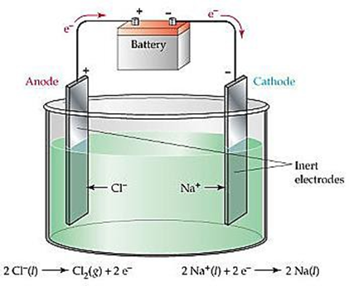Molten simply means a solid ionic compound melted into a liquid. As a molten liquid the ions are no longer in their lattice structure and can move in response to an electric field (ie conduct a current). Electrolysis of molten ionic compounds is simple to predict, as in their molten form the only possible REDOX reactants present are the ions of the ionic substance. For example, molten sodium chloride contains only sodium ions and chloride ions, and molten copper sulphate contains only copper (II) ions and Sulphate ions. Since there are only two ions in the electrolysis cell, the possible reactions are very easy to predict. One of the ions (the metallic ion) will undergo reduction to a metal, and the non-metal ion will undergo oxidation.

An example is molten (liquid) sodium chloride can be electrolysed to produce sodium metal and chlorine [gas](https://www.ck12.org/c/physical-science/gas?referrer=crossref). The electrolytic cell used in the process can be drawn traditionally as shwn in the diagram on the right.

In the diagram above on the right, sodium ions are being reduced to sodium metal, and the chloride Ions are being oxidised to chlorine gas. The overall reaction is

2Na+ + Cl-(aq) → 2Na(s) + Cl2(g) E0cell = -4.07 v

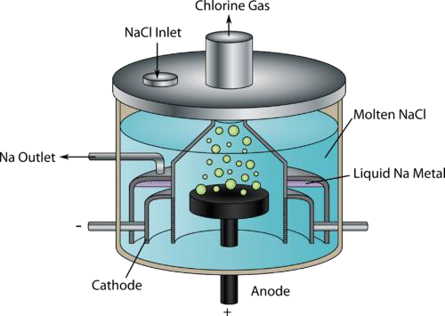However, any cell which produces sodium metal and Chlorine gas (both very dangerous chemicals), requires a special design and this electrolysis is carried out in a special cell called a Down’s cell – shown on the right.

In a Down’s cell, the [liquid](https://www.ck12.org/c/physical-science/liquid?referrer=crossref) sodium ions are reduced at the cathode to liquid sodium metal. At the anode, liquid chloride ions are oxidized to chlorine [gas](https://www.ck12.org/c/physical-science/gas?referrer=crossref). The reactions and cell potentials are shown below:

Oxidation (anode): 2Cl− → Cl + 2e− E0=−1.36 V

(l) 2(g)

Reduction (cathode): Na+ + e− → Na E0=−2.71 V

(l) (l)

Overall reaction: 2Na+ + 2Cl− → 2 Na + Cl E0 =−4.07 V

(l) (l) (l) 2(g) cell

The power source must supply over 4 volts to carry out this electrolysis. This reaction is one way to produce chlorine [gas](https://www.ck12.org/c/physical-science/gas?referrer=crossref) and is the only way to obtain pure sodium metal. Chlorine gas is widely used in cleaning, disinfecting, and in swimming pools.

# Electrolysis of Aqueous solutions (inert electrodes)

In Electrolysis, an aqueous solution is simply an ionic compound dissolved in water. Technically there are other aqueous solutions involving polar covalent compounds (such as sugar dissolved in water), but

these do not conduct electricity so cannot be used for electrolysis… so we will ignore these.

If an aqueous solution is used for electrolysis, the water is also a possible reactant in the electrolytic process as well as the metallic and non-metallic ions. This can make predicting the oxidant and the reductant more difficult than in a molten solution.

The general rule to apply in the electrolysis of aqueous solution is that the oxidation and reduction half reactions which combine to give the least negative (or largest) E0cell, are the oxidation and reduction reactions which will occur preferentially. Let’s look at how this works in an example… the electrolysis of aqueous NaCl (NaCl(aq)).

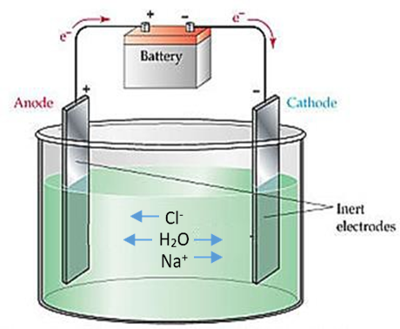**Electrolysis of aqueous Sodium Chloride**

Step 1:

List the possible reactants = Na+, Cl-, H2O

Step 2:

Identify reactions for these reactants in the table of standard electrode potentials.

Na+, Cl-, H2O – There are 3 possible reactants in this cell, and four ½ equations with these in them (water is in two).

Step 3:

Write all the E0 ½ reaction involving these reactants

Na+(aq) + e- ⇌ Na(s) −2.71 v

2H2O(l) + 2e- ⇌ H2(g) + 2OH-(aq) −0.83 v

 means this is a possible reactant present in the solution

O2(g) + 4H+(aq) + 4e- ⇌ 2H2O(l) +1.23 v

Cl2(g) + 2e- ⇌ 2Cl-(aq) +1.36 v

Step 4:

Label the reactions as Oxidation or Reduction – oxidation has a reactant of the right (and the half reaction goes from right to left), Reduction has ractants on the left (and the half reaction goes from left to right).

Na+(aq) + e- ⇌ Na(s) −2.71 v Possible **REDUCTION** (reactant on left, is an oxidant)

2H2O(l) + 2e- ⇌ H2(g) + 2OH-(aq) −0.83 v Possible **REDUCTION** (reactant on left, is an oxidant)

O2(g) + 4H+(aq) + 4e- ⇌ 2H2O(l) +1.23 v Possible **OXIDATION** (reactant on right, is an reductant)

Cl2(g) + 2e- ⇌ 2Cl-(aq) +1.36 v Possible **OXIDATION** (reactant on right, is an reductant)

Step 5: Determine the E0cell for each combination (RED + OX) of half reactions. (E0cell = E0reduction - E0oxidation)

Na+(aq) + e- ⇌ Na(s) −2.71 v **REDUCTION**

-3.94v

-4.07v

-2.19v

-2.06v

2H2O(l) + 2e- ⇌ H2(g) + 2OH-(aq) −0.83 v **REDUCTION**

O2(g) + 4H+(aq) + 4e- ⇌ 2H2O(l) +1.23 v **OXIDATION**

Cl2(g) + 2e- ⇌ 2Cl-(aq) +1.36 v **OXIDATION**

Step 6: Choosing the least negative combination of half reactions (1 reduction, 1 oxidation) and combine (balance the electrons!)

2H2O(l) + 2e- ⇌ H2(g) + 2OH-(aq) −0.83 v **REDUCTION**

-2.06v

O2(g) + 4H+(aq) + 4e- ⇌ 2H2O(l) +1.23 v **OXIDATION**

|  |
| --- |
| 4H2O(l) + 2H2O(l) ⇌ 2 H2(g) + 4OH-(aq) + O2(g) + 4H+(aq) |
| **2H2O(l) ⇌ 2 H2(g) + O2(g) E0 = -2.06 volts** |

So assuming a voltage of just over 2.06 volts, **and less than 2.19 volts is applied**, to an aqueous solution of sodium chloride, the reaction will be reduction of water to hydrogen gas at the cathode, and the oxidation of water to Oxygen gas at the anode. If a significantly higher voltage is applied (but still less than 3.94 v) then the oxidation of chloride ions to chlorine gas at the anode will also occur.

**HOWEVER** – the assumptions above are entirely dependent on the E0 values being correct, which is only true if the solutions are at 1M and 250C and 1 atm pressure. If a very concentrated solution of Sodium chloride solution was used (say concentrated seawater), the reduction of chloride ions is actually the preferred reaction. This is also a commercial way of producing sodium hydroxide solution – can you figure out how (see question 2 below)?

# Illustration of the electroplating of copper

# Electroplating

Electroplating is an application of electrolysis where the aim is to produce a coating of a metal onto the cathode. Many decorative objects like jewelry are manufactured with the aid of an electrolytic

process. Electroplating is a process in which a metal [ion](https://www.ck12.org/c/physical-science/ion?referrer=crossref) is reduced in an electrolytic cell and the [solid](https://www.ck12.org/c/physical-science/solid?referrer=crossref) metal is deposited onto a surface. The figure [below](https://www.ck12.org/book/ck-12-chemistry-concepts-intermediate/section/23.11/#x-ck12-OTgwNDUtMTM2NjM1NjI1MC0wNy03OC0xMg) shows a cell in which copper metal is to be plated onto a second metal.

The cell consists of a [solution](https://www.ck12.org/c/physical-science/solution?referrer=crossref) of copper sulfate and a strip of copper which acts as the anode. The metal (Me) is the cathode. The anode is connected to the positive electrode of a battery, while the metal is connected to the negative electrode. The copper anode is being oxidised, and the copper ions in solution are being reduced. For this reason, electroplating requires very little voltage as the reduction and oxidation half reactions have the same E0 values

When the [circuit](https://www.ck12.org/c/physical-science/circuit?referrer=crossref) is connected, copper metal from the anode is oxidized, allowing copper ions to enter the [solution](https://www.ck12.org/c/physical-science/solution?referrer=crossref).

anode: Cu (s) → Cu2+ + 2e−

(aq)

Meanwhile copper ions from the [solution](https://www.ck12.org/c/physical-science/solution?referrer=crossref) are reduced to copper metal on the surface of the cathode (the second metal):

cathode: Cu2+ + 2e− → Cu

(aq) (s)

The copper anode is being oxidised, and the copper ions in solution are being reduced. For this reason electroplating requires very little voltage as the reduction and oxidation half reactions have the same E0 values. The [concentration](https://www.ck12.org/c/physical-science/concentration?referrer=crossref) of copper ions in the solution is effectively constant. This is because the electroplating process transfers metal from the anode to the cathode of the cell. Other [metals](https://www.ck12.org/c/physical-science/metals?referrer=crossref) commonly plated onto objects include chromium, gold, silver, and platinum.

One specific application of this is the purification of copper metal. When copper is extracted from ores it is reasonably pure (~99% or more), like most metals. However, to be used as electrical wiring the copper must be very pure – and this is achieved by electroplating. The “nearly pure” copper is used as the anode, and pure copper (>99.9%) deposits at the cathode – similar to the diagram earlier except the Me cathode is a pure copper cathode. The impurities within the anode (“nearly pure” copper) either sink to the bottom of the electrolytic cell, or dissolve into the solution – depending on their E0 value.

**KEYNOTE – with predicting electrolysis… start by identifying the flow of electrons so you know where reduction and oxidation is occurring. Then identify the possible reactants (don’t forget water in aq solns). Write a possible ½ reaction for every reactant, label it RED or OX, and include their E0 values…the rest is Math!!**

## Checking for understanding:

1. For the electrolysis of aqueous Copper sulphate, determine:
   1. The ions present in the solution
   2. draw the electrolytic cell with labels

(b) The preferred cell reaction

1. products at the cathode and anode
2. Overall cell equation for the preferred reaction
3. Minimum voltage at 1M concentrations
4. If a very concentrated solution of sodium chloride underwent electrolysis at a voltage of 2.5 volts, what would be the products at the anode and cathode?
5. How would the minimum cell voltage and possible preferred reaction change if the concentrations of the aqueous solution was less than 1.0 M. Apply your logic to the electrolysis of both Sodium Chloride and Copper Sulphate.
6. Consider the electroplating of copper using “nearly pure” copper as an anode. What is the minimum voltage for this reaction to occur? List two metals which would dissolve in the